Modeling Template – Teacher Instructions

- This template should be used throughout the module whenever students are creating or refining their models of energy processes and energy balance both at the global and local scale.
- The template scaffolds students’ thinking by asking for the big idea (What are you modeling?), having students describe what they will include in their model (List concepts), drawing their actual model – which should be a visual/pictorial representation of their ideas; and finally asking students to describe their model using their own words.
- Students are asked to generate both local and global models. The local model should include elements specific to a City or other built community and the global model should “zoom out” and include elements related to the broader global systems being discussed.
- Students’ models should change overtime from the beginning of the module until the end. It is appropriate for students to have access to their previous models to revise and add new ideas as the unit progresses.
- A useful scaffold may include a student-centered discussion and student questioning to generate a class list of “important concepts” that students can then incorporate into their drawings. It is ok and likely that students’ models will differ initially. They will likely converge toward similar models as the module progresses.
- Below are sample models that students may create. These are not intended to be the ideal samples; your students may include more or less detail. Use probing questions to encourage students to consider additional concepts to include in their models throughout the unit, such as: Are there other sources of energy you might include? Where does the energy in your model come from; where does it go? Are there other features of the City/Earth that you could include in your model?

What are you modeling?

What impacts surface temperatures in Baltimore (from Lesson 1 investigation)?
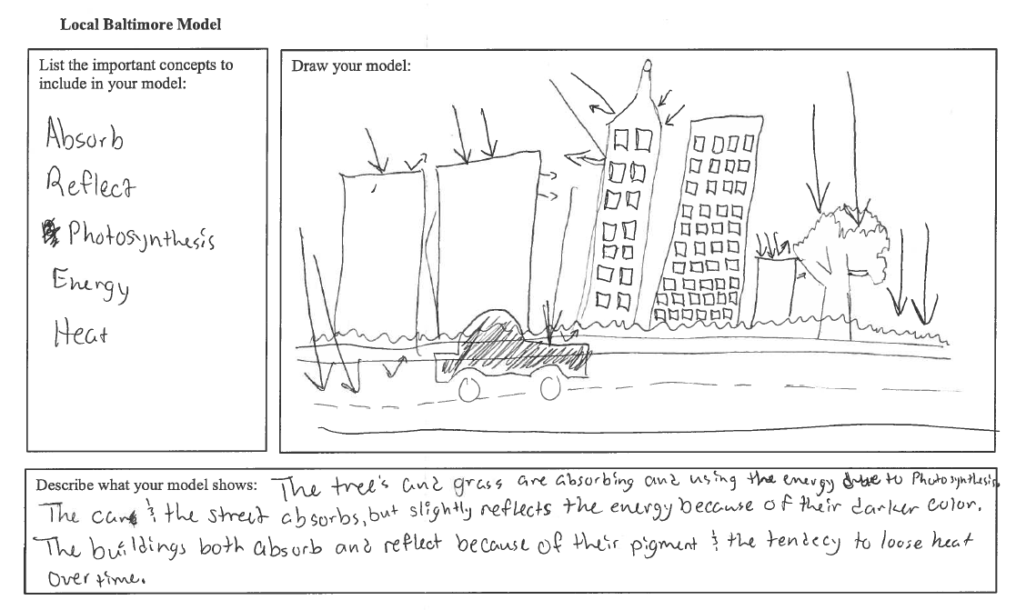
What are you modeling?

What impacts the surface temperature of Earth (from Lesson 1)?

