Name ______________________ Date ________

Lesson 3: Which fish should I eat?
The Hudson River is a complicated ecosystem, and that makes deciding whether to eat fish complicated too! In this lesson, we will examine four species of fish: Striped bass, Catfish (channel and white), Brown bullhead, and Yellow perch.

Part 1: Review Questions
- List the factors that can affect PCB concentrations in living organisms:
Fat level, age, size, where they live, what they eat, how much of their lives they spend in the Hudson

- Make a guess about which species will have the highest PCB concentrations, and which species will have the lowest, using your background knowledge of fish and the reading from Lesson 1. Give your highest species a #1, and your lowest species a #4. Be ready to defend your choice!

_____ Striped bass _____ Catfish ____ Yellow Perch ____ Brown Bullhead

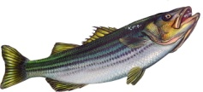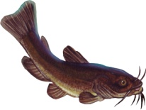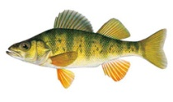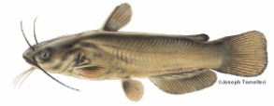

Part 2: Species Cards
You will receive a Species Information Card for one of the species above. Review the information in your small group, and be sure you understand all the information about your fish.

- Calculate the average % lipid (fat) levels from the four years of data that are provided:

_SB:4.22 Cat:6.11 YP:0. 54 BB:2.3_______

2. Then, fill out the graphic organizer below as your classmates share information about their fish:
 | Yellow perch | Catfish | Striped bass | Brown bullhead
Size | X Small (<8 in)  □Medium (8-20 in)  □Large (>20 in) | □Small (<8 in)  X Medium (8-20 in)  □Large (>20 in) | □Small (<8 in)  □Medium (8-20 in)  X Large (>20 in) | □Small (<8 in)  X Medium (8-20 in)  □Large (>20 in)
Lifespan | X < 9 years  □ 9-20 years  □ > 20 years | □ < 9 years  X 9-20 years  □ > 20 years | □ < 9 years  □ 9-20 years  X > 20 years | X < 9 years  □ 9-20 years  □ > 20 years
Habitat | X Fresh  X Brackish  □Salty | X Fresh  X Brackish  □Salty | X Fresh  X Brackish  X Salty | X Fresh  X Brackish  □Salty
Diadromous? | □Yes X No | □Yes X No | X Yes □ No | □Yes X No
Life cycle | X Lives near "home"  □Migrates long distances | XLives near "home"  □Migrates long distances | □Lives near "home"  X Migrates long distances | XLives near "home"  □Migrates long distances
Feeding | □Primary and secondary consumer  X Secondary only | X Primary and secondary consumer  □Secondary only | □Primary and secondary consumer  X Secondary only | X Primary and secondary consumer  □Secondary only
Average % lipid: | See above | See above | See above | See above
Average % lipid category | X Low (< 1%)  □Medium (1-5%)  □High (> 5%) | □Low (< 1%)  □Medium (1-5%)  X High (> 5%) | □Low (< 1%)  X Medium (1-5%)  □High (> 5%) | □Low (< 1%)  X Medium (1-5%)  □High (> 5%)
Using this information, predict whether each fish species will have "low" or "high" levels of PCBs. | X Low  □High | □Low  X High | □Low  □High | □Low  □High
Explain your reasoning for your choice. | Because YP are small, short-lived, and don’t have a lot of fat, they should have low PCBs | Because catfish are medium sized, long-lived, stay in the Hudson and have a lot of fat, they should have high PCBs | Because SB are large and long-lived and have some fat, they could have high PCBs, but they leave the Hudson and reduce their exposure so they may also have low PCBs | Because BB are medium sized, stay in the Hudson and have some fat, they could have high PCBs, but they are short-lived so PCBs could be low also.

3. Which fish do you think will have the highest PCB concentration, given the situation(s) below? Circle your answer for each question.
  - You catch two fish: a striped bass and a brown bullhead. Based only on their feeding habits, which species do you think will have the higher PCB concentration?

  - You catch two fish, one that is 36 inches long and one that is 4 inches long. Based only on their size, which fish do you think will have the higher PCB concentration?

  - You catch two fish of the same size: a catfish and a striped bass. Based only on their migratory habits, which species do you think will have the higher PCB concentration?

  - You catch two fish of the same size: a catfish and a brown bullhead. Based only on their % lipid levels, which do you think will have the higher PCB concentration?

Part 3: PCB Data
You will receive PCB data for your fish species for 2011. Select at least 15 data points and plot them as points above the name of your fish species. Be ready to share your results with the class. These fish were collected in Poughkeepsie and Catskill, NY.
Then, calculate an average for your data and mark it on the graph: ______________
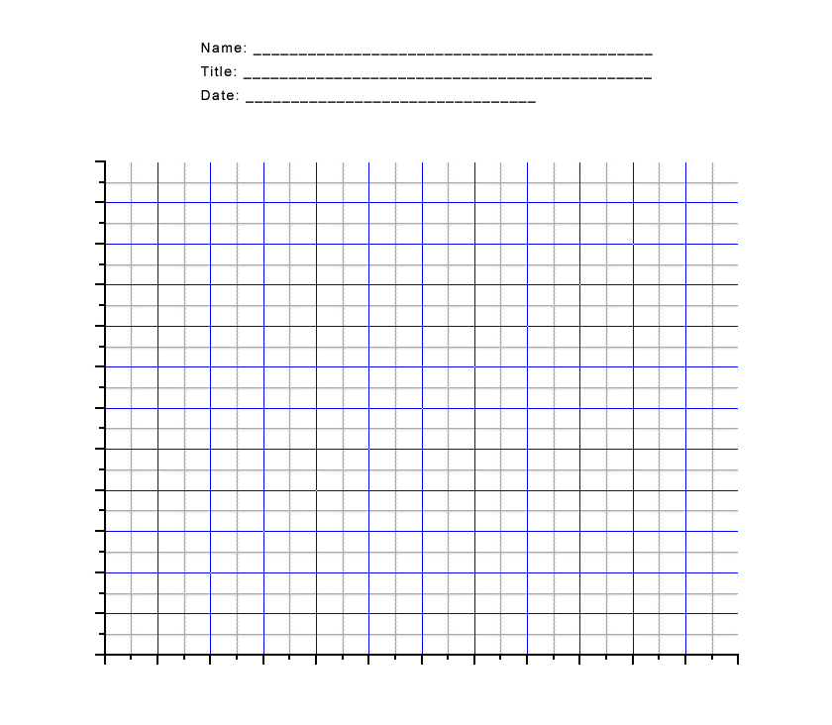

Part 4: Summarizing Results
- Why do you think there were differences between the PCB contamination levels in your fish species in 2011? Include at least two possible reasons.
Fat level, age, size, where they live, what they eat, how much of their lives they spend in the Hudson

- Create a summary graph of the four fish species for 2011. You may do this as a class or individually. Based on this graph only, which fish species has the highest PCB levels, and why?
Catfish, because more catfish samples have high levels

- Here are data for all of the four fish species, for four years. These data are averages of multiple samples from each year, from all locations. The number of samples that were used to calculate each average is provided in the table:

 | # samples 2001 | # samples 2005 | # samples 2008 | # samples 2011
Catfish | 15 | 27 | 27 | 22
Striped bass | 251 | 250 | 214 | 130
Brown bullhead | 23 | 19 | 21 | 21
Yellow perch | 52 | 19 | 20 | 19

a. Which species has the highest overall PCB contamination level (claim)? ___Catfish_____
b. What are some potential limitations of this dataset?
It doesn’t account for differences in location that may influence the level of PCBs and increase variability, and also the size and age of fish

c. In order to be more confident in your claim, what else would you like to know?
Where the fish were caught and at what time of year, how big and old they were

- Your teacher will show you a graph of the average % lipid levels in the four fish species. Use these data to create a scientific argument (claim, evidence, & reasoning) for the relationship between PCB levels in fish and % lipid levels.
Claim: when lipid levels go up, PCBs go up
Evidence: catfish have the highest lipid levels and PCBs, YP have the lowest lipids and also the lowest PCBs. There is a strong correlation between fat and PCBs
Reasoning: These factors vary together, which indicates that they may be related to each other

- Based on what you have learned, what do you think is the most important reason that species differ in their PCB contaminant level? Explain your reasoning.
Lipid level, since this is most strongly correlated with PCB level

- Based on this activity, do you now feel more or less comfortable eating fish from the Hudson River? Why or why not? If you are not comfortable, what else would you need to know in order to make a decision?
This is an opinion question

