Name ______________________ Date ____________
Creating a Woodland Study Plot
Background
A plant community includes all of the plants living in a given place. In this lab, you will answer the question: What species of trees live in your schoolyard? Knowing which trees live in your schoolyard, how large they are, and their general health will provide you with some basic information about this ecosystem which you can then use to answer additional questions.
Materials
Materials:
- One 5m tape or marked rope
- One 30m tape or marked rope
- Meter stick or DBH height stick (1.3m high)
- DBH measuring tape
- Tree and shrub identification books and keys, camera
- ½ in PVC pipe stakes or flagging (to mark ends of your transect)
- For tree marking:
  - Colored flagging tape
  - Permanent marker
  - OR: tree tags
  - ½ in aluminum nails
  - Ballpoint pen (if using write-on aluminum tags)
- Data sheets and clip boards
- Hammer
- Tool apron or bag for carrying supplies
- Map of your area

Before you begin, make a prediction about how many different tree species there are in your plot: ______________

A. Plot location(s)
- As a class, decide how many plots you will create, and where; mark these on your map. We recommend setting up at least two plots per class.
- At minimum, you need three people per plot. The jobs for each group are:
  - Marker: Marking & measuring the tree
  - Identifier: Identifying the tree
  - Recorder: Writing down data

A. Lay the Plot: 10x30m
- Stretch out a tape measure for 30m. Make sure this is as straight as possible!
- Place a permanent stake at the ends of your transect. Label the plot so that when you return to it in the future, you’ll know which one you’re visiting.
- Only measure trees that are larger than 10cm DBH.
- To determine the edges of your plot, use the 5m tape on either side of the 30m transect tape. Have two people hold the ends of the 5m tape and walk along the 30m transect.
- Stop at each tree you encounter and decide if it is in the plot AND large enough to measure.
- If a tree is more than halfway outside of the plot, do not count it.

B. Tree Measurements – record all your data!
- Measure the DBH of any tree that is greater than 10cm.
- To measure Diameter Breast Height: use a DBH stick or measure 1.3m from the ground. Record the DBH on your data sheet.
- Approximately 10cm above the DBH line, anchor a tag into the tree using a roofing nail. The tag should identify the tree by number (use a ballpoint pen to write a unique number on each tree tag, or use the pre-numbered tags).
Note: Do not measure dead trees. If a tree splits into two branches below the DBH line, measure each stem as if it were its own tree.
- Record the condition of the tree:
  - Excellent
  - Good
  - Fair
  - Poor
  - Dead or Dying
- Record the amount of sun the tree receives
  - Full
  - Partial
  - Shade
- Record any additional notes, such as whether you believe this tree was deliberately planted, if you see any evidence of disease or herbivory, fruits or seeds, etc.
- Repeat this procedure for all the trees in your plot.
- Mark the location of the trees using the grid provided.
Identify Trees:
- Identify the known trees and record them on your datasheet.
- For unknown trees, use tree guides or take pictures and samples to help you identify your tree.
- Record all of your species. A tree species list with codes is provided.

Tree ID Data Sheet
Student Name:
Date/time:
Plot name/number:
Plot location at 0m (lat/long or other descriptors):

Tree Tag # | Tree ID (species) | DBH (cm) | Condition  - Excellent  - Good  - Fair  - Poor  - Dead/dying | Sun  - Full  - Partial  - Shade | Notes

Use this grid to identify where the trees in your plot are located. Each tree will receive a location with an (x,y) coordinate. For example, if tree #1 is the first tree in your plot on the left hand side of your transect tape, it might have a coordinate of (2.4m, -1.3), which is marked on the grid below with an “x”. Make sure you label each tree on this grid with its Tag#. You should also record the latitude and longitude of the starting location of your transect tape (if possible). A free app is available called GPS Essentials which will provide coordinates on your phone.

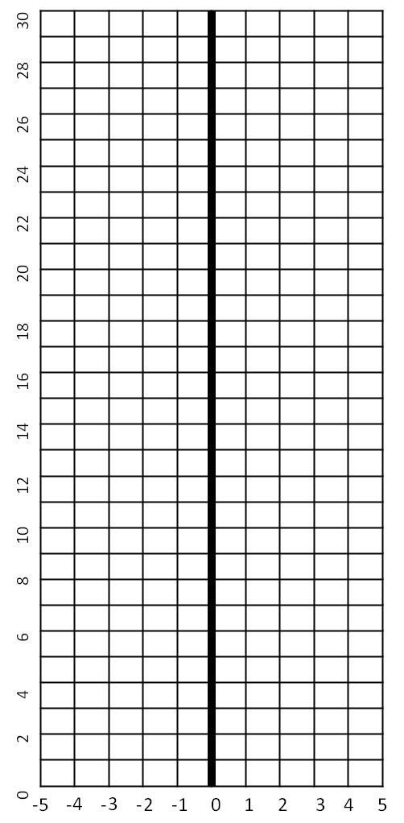
Latitude: _________ Longitude: ________

Discussion Questions:

- What is the species richness of your school woodland plot? How does this compare with your predictions?
- Describe the differences in biodiversity between your plots.
- What was the most abundant species? Describe this species – is it native or invasive? How do you think it got here?
- What is the age distribution of the trees in your woodland? Use the DBH measurements to help you – smaller trees tend to have smaller DBH sizes.
- What can you tell about the composition of your woodland, based on your measurements?
- Based on your observations, how healthy is your woodland? Explain your answer.
- If you come back to this woodland in 20 years, how do you think it will have changed? Explain your answer.

Extensions:
iTree
- Are you curious about the ecosystem services provided by the trees in your schoolyard? To find out more, use iTree Design: http://www.itreetools.org/design.php .
- You’ll need to use the map feature to find your school.
- Next, add the boundaries of your school building using the drawing tools.
- Finally, add the trees in your schoolyard, including the species and size. This will allow you to find out how the trees are benefitting your school.

iNaturalist
- Join the Hudson Valley Tree Guide in iNaturalist: http://www.inaturalist.org/projects/hudson-valley-tree-guide .
- Once you have joined the project, you can add observations of the trees you have found in your schoolyard.
- Make sure to add at least one picture from your tree!

Carbon Storage
Calculate the amount of carbon that is being stored by the trees in your plot, and compare carbon storage by species. Use the equations provided by your teacher.

