Seed Dispersal Investigation
Name: __________________ Date __________

Species name: _________________________
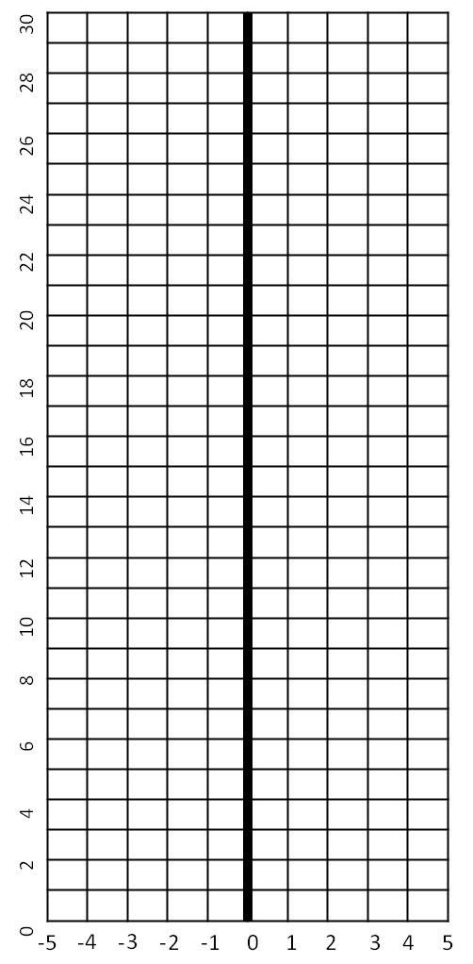

Based on your map, predict what your seed type looks like and how it might be dispersed.
__________________________________________________________________________________________________________________________________________________________________________________________________________________________________________
Background: After fertilization, seeds will form. It is important for the seeds to be spread (dispersed) away from each other and from the parent plant. This helps to avoid overcrowding and the competition for light, water and nutrients that would result. Dispersal also enables species to take advantage of new opportunities and to survive if conditions for the parent plant become unsuitable. Plants have a variety of ways in which they disperse their seeds, or the fruits containing the seeds. Four main groups of dispersal mechanisms can be recognized: animal, wind, water and self-dispersal. The size, shape and color of the fruit and seed, together with other features, reflect the method of dispersal.

Initial Observations:
Describe the seed: ______________________________________________________________________________
____________________________________________________________________________________________________________________________________________________________
Predict how far from the base of the tree the greatest number of seeds will be found: ____________________________

Procedure:
- Select at least two trees of the same species. For each:
  - Set up a transect line from the base of the study tree that extends to the edge of the canopy and at least 10m beyond.
  - Every one to five meters along your transect tape, place a 1-m quadrat (or a hula-hoop) and collect all the seeds within the measurement area. Determine the number of samples you will take based on the size of the tree canopy. For example, if you have a small tree, you may want to sample every meter – if you have a large tree, every 2 or 3 meters may work better.
  - Count the number of seeds within each quadrat.
  - Collect the seeds (or a subset; collect at least 10 seeds from each quadrat). Place these seeds in a labeled plastic bag.
2. Weigh three seeds from each quadrat.

Tree Species:_______________________
Quadrat # | Distance from Tree | Number of seeds | Seed Weight | Average Seed Weight
1
2
3
4
5
6
7
8

6. Create a line graph of seeds vs. distance from the tree, and a graph of the average weight of the seeds vs distance from the tree.

Questions:
- At what distance did you find the most number of seeds? ______________________________
- Does this support your prediction? If not, how did your prediction differ? ___________________________________________________________________________
___________________________________________________________________________
___________________________________________________________________________
- What specific qualities does the seed of your tree species have that aided in its dispersal? ___________________________________________________________________________
______________________________________________________________________________________________________________________________________________________
- As a class, fill in the data table on the next page on dispersal of all the tree species. Compare and contrast your data with data groups that gathered data from other trees. Are there similarities or differences? Explain your answer using specific data.
______________________________________________________________________________________________________________________________________________________
___________________________________________________________________________
___________________________________________________________________________

Group # | Species | Distance of quadrant with the greatest number of seeds | Average seed weight

