Task: Draw a cartoon series showing your understanding of what happens to leaves from a tree after they drop and fall to the forest floor. Include an explanation under each diagram and INCLUDE AS MANY RELEVANT SCIENCE CONCEPTS AS YOU CAN!
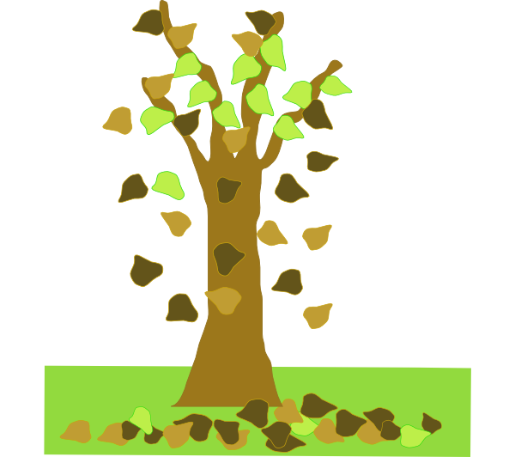
The leaf falls from the tree at a particular time of the year depending on the type of tree. The leaf falls to the forest floor.

