Junior Data Jam Competition 2023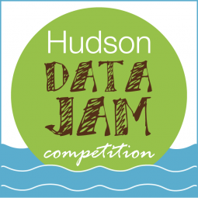

Written Report Form

**Team Information**

Project Title:

Name of Dataset(s):

Level of Dataset(s):

Team Advisor's Name(s):

Team Members’ Names (First and Last):

*All written components for Junior Data Jam submissions must include the following information. You may fill in this document, or create a separate file. One paragraph containing all necessary information is sufficient. See the* [***JUNIOR DATA JAM JUDGING RUBRIC***](https://www.caryinstitute.org/sites/default/files/public/downloads/junior_dj_rubric_2022.pdf) *for more details on what to include in each section. You must also complete a creative project for your entry to be judged.*

*Reports should be no more than 10 pages including figures, tables and text (single spaced, font at least 11 pt, margins of at least 1”)*

**1. Title** --- with all participant names and grades

**2. Data Representation(s)** – graph, chart, or other type of data visualization/summary

**3. Data Trend(s) or Comparison(s)** – described, referring to representation(s)

**4. Data Interpretation –** explanation of why data trends or differences occurred

**5. Explanation of Creative Project**

**6. References** – the source of your chosen dataset

**7. Link to YouTube video** (if applicable)